###### IMAGE GALLERY

###### A MINI PROJECT REPORT

###### Submitted by

###### Group: G30

**KESHAV GUPTA, 2410993043,**

**KUSHAN GARG, 2410993053,**

**YASHIT MITTAL, 2410993075,**

###### *in partial fulfillment for the award of degree*

###### *of*

###### 

###### BACHELEOR OF ENGINEERING

***in***

CSE-AI



**CHITKARA UNIVERSITY**

**CHANDIGARH-PATIALA NATIONAL HIGHWAY**

**RAJPURA (PATIALA) PUNJAB-140401 (INDIA)**

###### September 2024

###### TABLE OF CONTENTS

|  |  |  |
| --- | --- | --- |
| Sr.no | **Section** | **Page no** |
| **1.** | Introduction | 1 |
| **2.** | Problem Statement | 2 |
| **3.** | Goals | 3 |
| **4.** | Features | 4 |
| **5.** | Tech Stacks | 5 |
| **6.** | Results | 6-13 |
| **7.** | References | 14 |
| **8.** | Conclusions | 15 |

###### 

**INTRODUCTION**

In today's digital world, images are often more impactful than words, and there is a need for a well-organized and visually appealing site to share images. Our Image Gallery Website Project is addressing this problem head on with a full-featured, responsive, user-friendly experience for uploading, organizing, and sharing images.

This project is built for many different types of users: photographers, designers, businesses or casual users creating a personalize or professional online gallery. Additionally, this site allows the users to showcase their visual content and to engage with their images in a unique web experience using the latest web technology.

**PROBLEM STATEMENT**

* + Today's world is image-centric. Everyone needs a simple, accessible, and secure solution to manage and display images online, including individuals and businesses as well as creative professionals. Current image management tools miss the mark in several key areas, including simplicity, customization, searchability, and scope.
  + The **Image Gallery Website Project** aims to solve these issues by providing an affordable, feature-rich platform that emphasizes ease of use, advanced organization capabilities, robust security, and a mobile-responsive design. Our goal is to create a scalable solution that empowers users to efficiently manage and share their images while maintaining full control over privacy and presentation.
  + The present undertaking can be described as a balance between design, functionality and user experience. We aim at providing a solution that goes beyond the mere practical aspect of the users and allows them to showcase their visual narratives in a more professional and exciting way.

**GOALS**

* + To develop a visually attractive, user-friendly platform to manage and display images on the Internet.
  + To provide advanced features such as image grouping (or categories), search, and tagging for an efficient organization.
  + To create a responsive and mobile-friendly interface that works well across a wide range of devices.
  + To establish high standards of security and privacy for user-uploaded content.
  + To develop a reliable, high-performance website that can accommodate large numbers of images and users.

**FEATURES**

**User-Friendly Interface**: Designed for simplicity, the intuitive dashboard allows users of all levels to easily manage images, create galleries, and personalize content with ease.

**Advanced Search and Filtering**: Users can quickly sort and organize large image collections using filters like categories, tags, dates, and metadata for efficient searching.

**Responsive Design**: Optimized for all screen sizes, the platform ensures a consistent visual experience across mobile, tablet, and desktop devices.

**High-Quality Image Display**: Images are optimized for fast loading while maintaining high quality, ensuring a smooth and visually appealing browsing experience.

**TECH STACKS**

**HTML STRUCTURE OF WEB:**

HTML forms the foundation of the website, providing the structural layout for all content.

**ROLE**: Organizes images into grids and galleries. And defines the basic elements like text, buttons, and links.

**BENEFITS:** Ensures accessible and well-organized content along with optimization for SEO and cross-browser compatibility

**CSS-DESIGNING**:

CSS is responsible for styling and designing the visual aspects of the website.

**ROLE**: Controls the appearance of the image galleries, text, and layout along with Implements responsive design, ensuring the website looks great on all devices.

**BENEFITS**: Creates a visually appealing and consistent design.

**RESPONSIVE AND INTERACTIVE UI WITH CSS**:

CSS ensures that the website adapts seamlessly to different screen sizes.

**ROLE**: Media queries are used to make the website fully responsive for mobile, tablet, and desktop devices. And Hover effects and other interactive styles enhance the user experience.

**BENEFIT:** Smooth, engaging interactions. And Optimized layouts for every device.

**RESULTS WITH EXPLANATION**

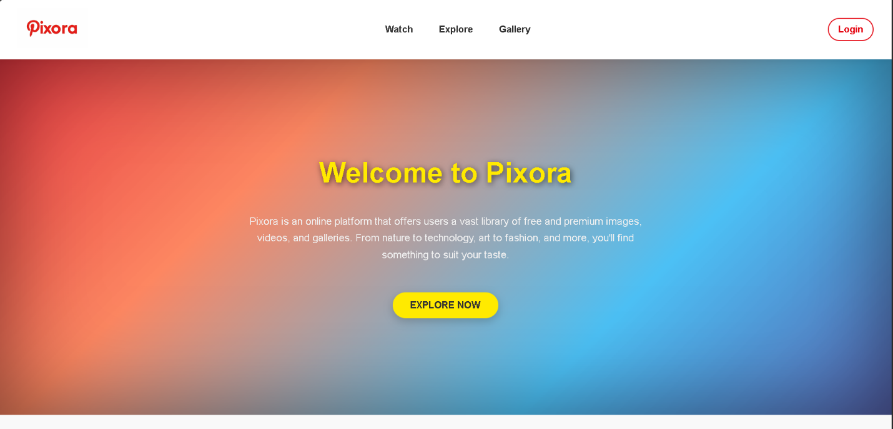

This Pixora landing page introduces users to the platform, which offers an extensive library of free and premium images, videos, and curated galleries. The page has a clean and minimalist design with a soft, gradient background that transitions from warm red to cool blue, creating a visually appealing effect. The bold "Welcome to Pixora" header immediately captures attention, followed by a brief description of Pixora's offerings—highlighting a diverse selection of content that includes nature, technology, art, and fashion.

The central "Explore Now" button, styled in a bright yellow with a subtle drop shadow, invites users to dive into Pixora’s content. The top navigation bar includes links to main sections like "Watch," "Explore," and the exclusive "Gallery" page, making it easy for users to navigate. A red-outlined "Login" button is positioned in the top-right corner, allowing quick access for registered users. The overall layout is modern and welcoming, encouraging exploration and engagement with Pixora's vast digital media collection.

**LOGIN PAGE**

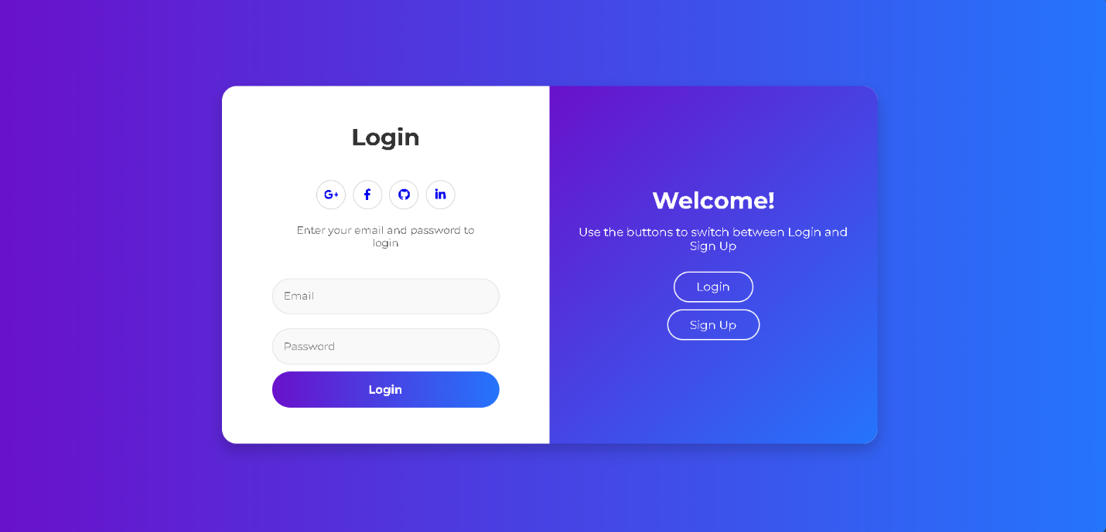

This page is the login and sign-up interface for Pixora. It features a sleek, split-screen design with a vibrant purple-to-blue gradient background. The left side displays the "Login" form, where users can sign in using their email and password. It also includes social media login options, represented by icons for Google, Facebook, GitHub, and LinkedIn, allowing users to quickly log in through these platforms.

The right-side welcomes users with a "Welcome!" message and provides buttons to toggle between the "Login" and "Sign Up" views, guiding users to either log in or create a new account. The interface uses soft shadows and rounded input fields, giving it a modern and user-friendly appearance. The design is intuitive, with clear visual cues that make it easy for users to navigate and access their accounts.

**WATCH PAGE**

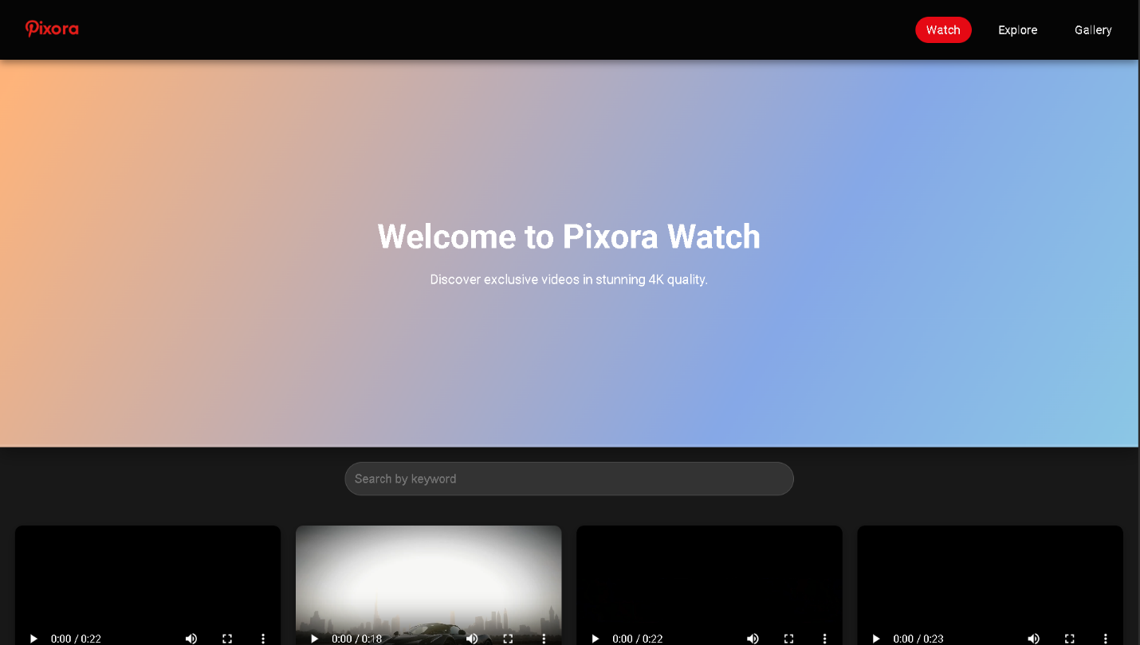

This webpage introduces users to the "Pixora Watch" section, which appears to be dedicated to high-quality video content. The header features a dark background with the Pixora logo and navigation options, including "Watch," "Explore," and "Gallery." The "Watch" tab is highlighted in red, indicating the current section.

The main content area features a large welcome message, "Welcome to Pixora Watch," along with a brief description that invites users to "Discover exclusive videos in stunning 4K quality." This suggests that Pixora Watch offers premium video content, possibly for art, cultural events, or visual storytelling.

Below the welcome message, a grid of video thumbnails is displayed, each with a playtime overlay , hinting at short, high-definition video clips. There’s also a search bar labeled "Search by keyword," allowing users to find specific videos. The overall layout emphasizes easy access to high-quality videos, with a gradient background in soft orange and blue tones adding a modern, appealing aesthetic to the page.

**EXPLORE PAGE**

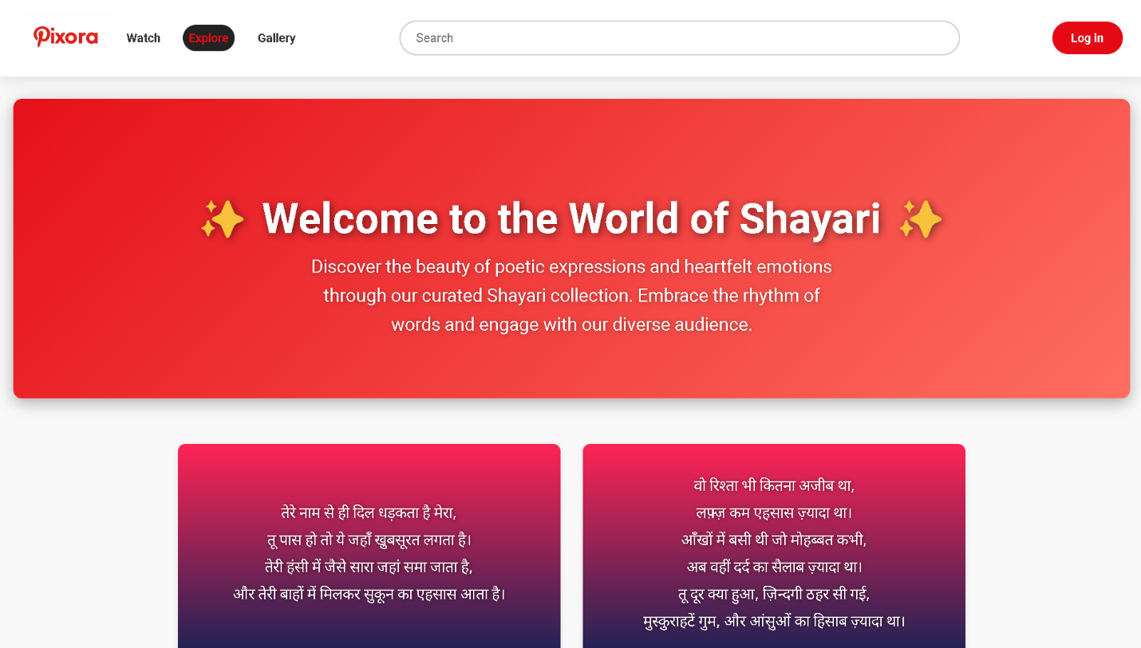

This webpage on Pixora is dedicated to showcasing a collection of Shayari, or poetic expressions, which capture heartfelt emotions and cultural nuances. The top banner, styled in a vibrant red background, welcomes users with the message, "Welcome to the World of Shayari," accompanied by sparkles that add a touch of elegance and allure to the page. Below the heading, a brief description invites users to explore the rhythm and beauty of Shayari, encouraging them to engage with the platform's curated collection.

The page layout features individual Shayari cards displayed in a grid, each with a gradient background that transitions from deep pink to purple, creating a visually pleasing contrast. Each card contains short Shayari verses written in Hindi, reflecting themes of love, longing, and introspection. The cards are neatly spaced and organized, allowing users to browse and immerse themselves in each piece of poetry.

At the top of the page, a navigation bar provides links to other sections of Pixora, including "Watch," "Explore," and "Gallery." A search bar allows users to find specific content, while a prominent red "Log in" button on the right offers easy access to user accounts. The design is visually engaging, with a modern aesthetic that enhances the cultural richness of Shayari and invites deeper interaction with the content.

**GALLERY PAGE**

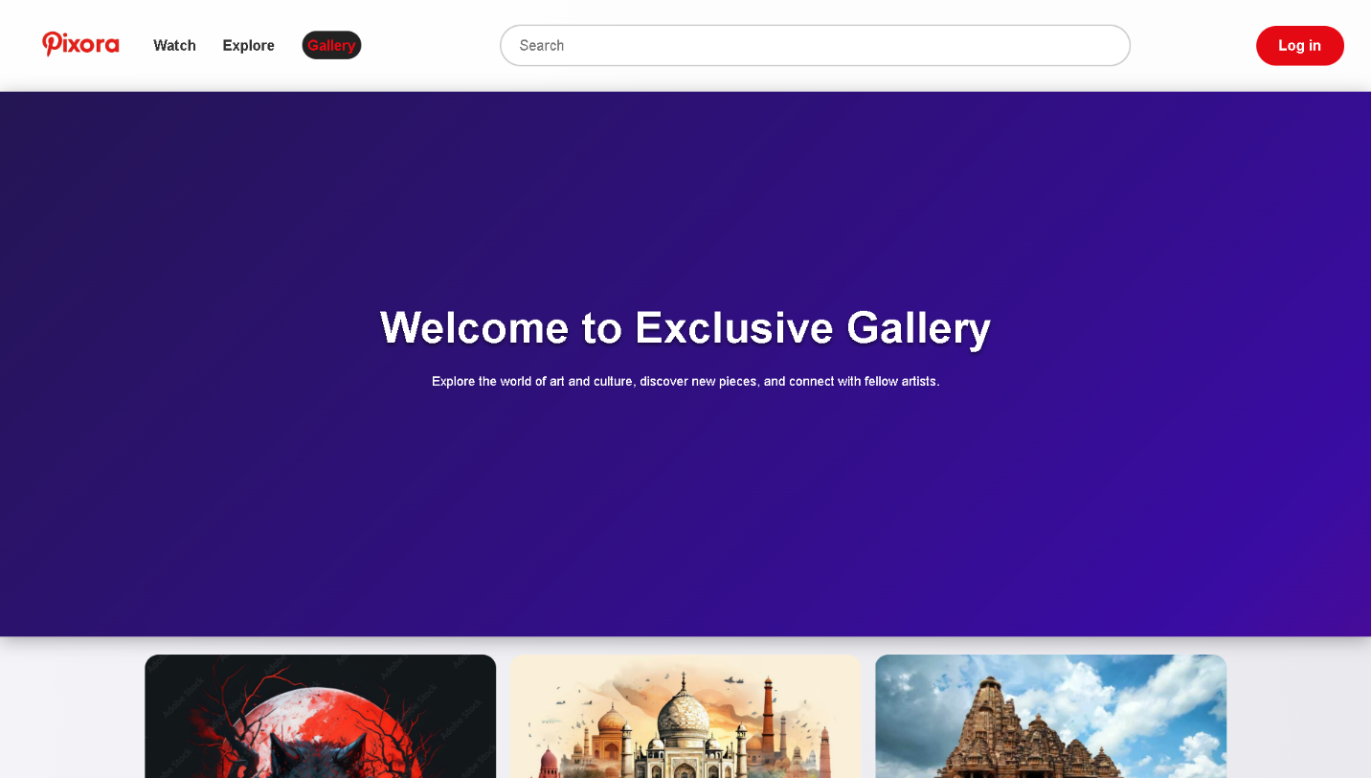

This webpage serves as the entry point to Pixora's "Exclusive Gallery," a section dedicated to showcasing a curated selection of art and cultural imagery. At the top, the Pixora logo and navigation menu offer easy access to other sections, such as "Watch" and "Explore," along with a highlighted "Gallery" tab, indicating the user's current section. A search bar provides functionality for finding specific content, and a prominent red "Log in" button encourages users to sign in for a personalized experience.

The central area features a welcome message, "Welcome to Exclusive Gallery," which introduces the purpose of this gallery: to let users explore art, discover new pieces, and connect with like-minded individuals. This suggests a community-focused experience centered on visual discovery. Below the welcome message, a grid layout displays various images, hinting at the diversity of content users can expect to find within the gallery—such as digital art, cultural landmarks, and other visually rich pieces. The design invites users to scroll down and explore more of the exclusive content available on Pixora.

**ABOUT US PAGE**

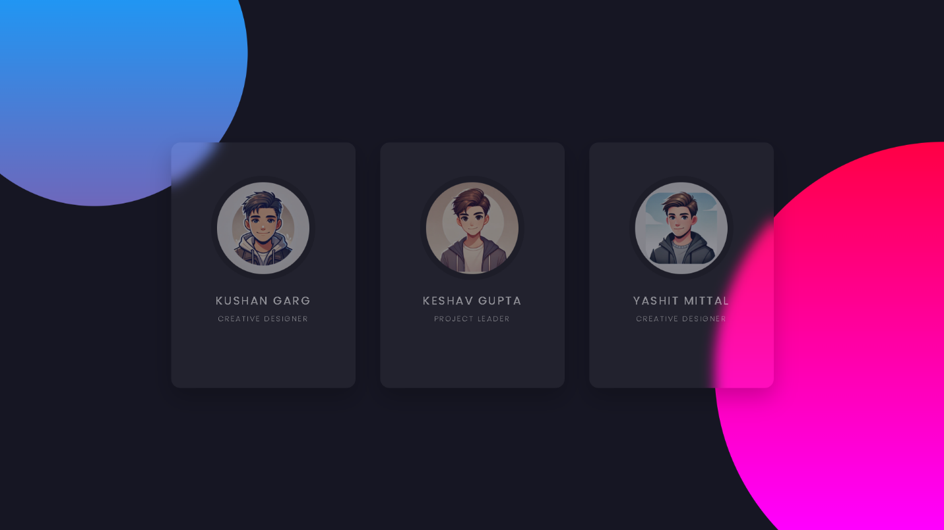

This webpage section appears to be a team introduction or "About Us" panel for Pixora, showcasing three key team members with their roles and stylized avatars. The layout features individual profile cards set against a dark background, with vibrant, overlapping gradients in blue and pink, adding a modern and visually striking effect.

Each profile card highlights a team member’s name, role, and a circular avatar image:

1. **Kushan Garg** - Listed as a "Creative Designer," suggesting a role in the artistic or visual design of the platform.
2. **Keshav Gupta** - Identified as the "Project Leader," likely overseeing project direction, planning, and coordination.
3. **Yashit Mittal** - Also a "Creative Designer," involved in the design aspects alongside Kushan.

The clean, minimalistic design emphasizes the avatars and text, presenting a professional but approachable impression of the team. The color gradients and dark theme reflect a sleek, creative brand image, aligning with Pixora's focus on art and culture.

**TERMS PAGES**

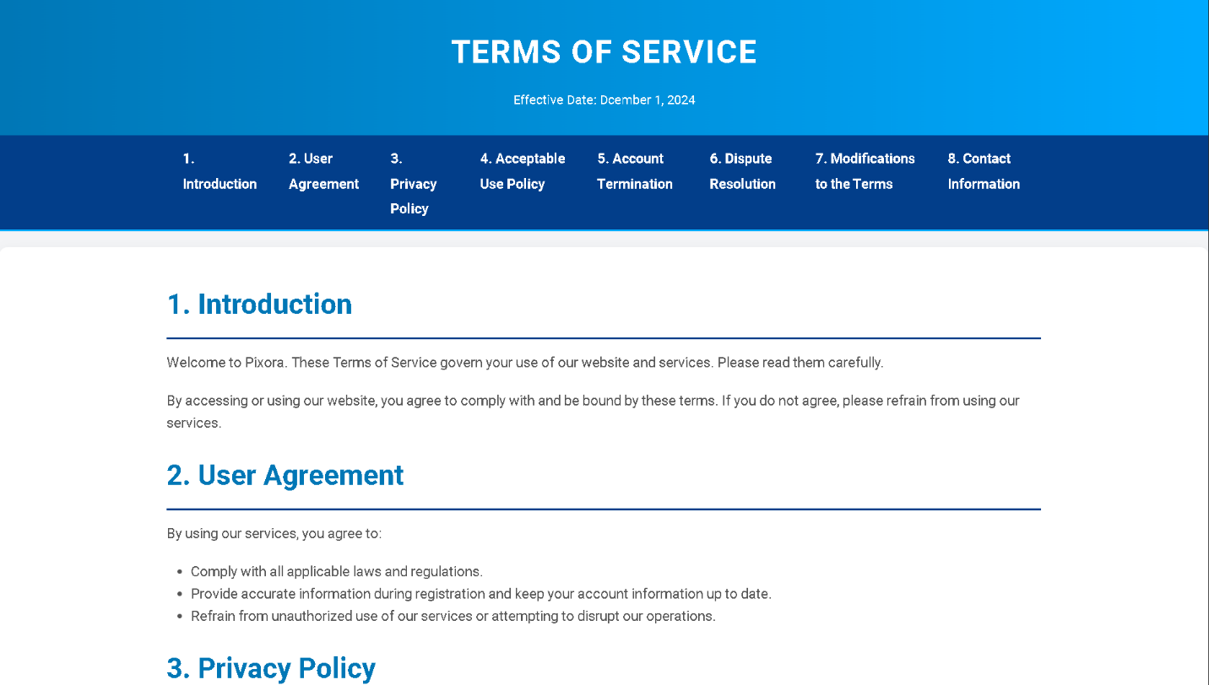

This **Terms of Service** page for **Pixora** outlines the rules users must follow while using the website. Key sections include:

1. **Introduction** – Welcomes users and explains that using the site means agreeing to these terms.
2. **User Agreement** – Lists requirements, like following laws, providing accurate information, and avoiding misuse of services.
3. **Privacy Policy** – Covers how user data is handled (details not shown here).

A navigation bar at the top provides quick access to all sections of the Terms of Service.

**PRIVACY POLICY**

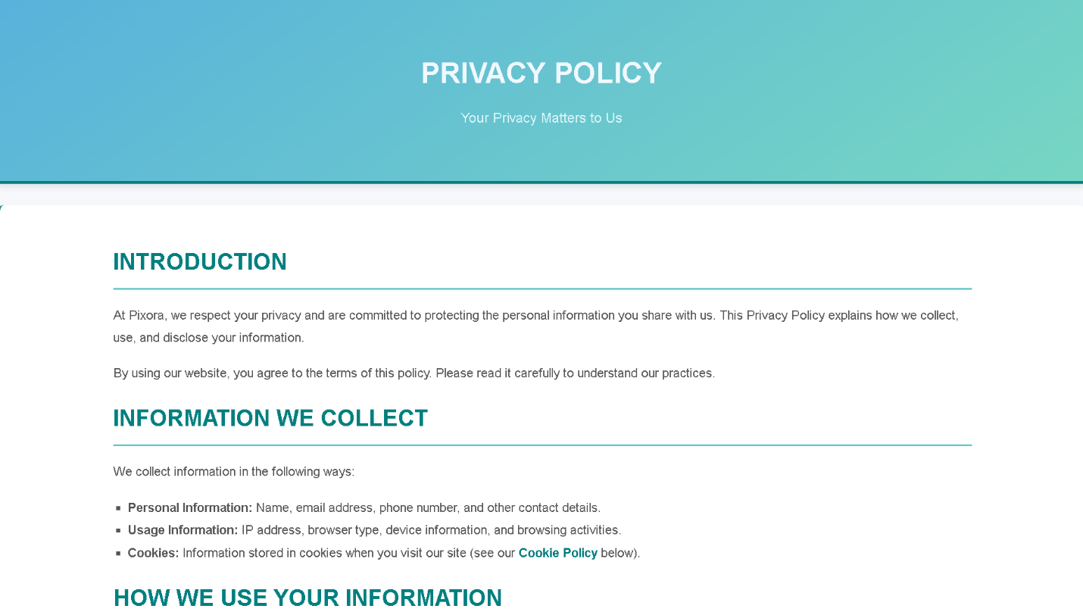

This **Privacy Policy** page for **Pixora** outlines the platform’s commitment to user privacy and describes how personal information is handled. Key sections include:

1. **Introduction** – Assures users that their privacy is respected and explains that using the site implies agreement with this policy.
2. **Information We Collect** – Lists the types of information collected, including:
   * **Personal Information** like name, email, and phone number.
   * **Usage Information** such as IP address and browsing activities.
   * **Cookies** for storing site-related data.
3. **How We Use Your Information** – Details on this are not shown here but would explain the purposes for using collected data.

The layout is user-friendly and organized for easy navigation.

**REFRENCES**

Throughout the development of the **Image Gallery Website Project**, various resources were consulted to ensure the implementation of best practices in web development. The following references provided valuable insights and guidance:

**1. Google Search**

Used extensively to gather information, troubleshoot issues, and explore examples of similar projects and best practices for HTML and CSS implementation.

**2. Official Documentation**

**HTML and CSS Documentation:** Resources from MDN Web Docs and W3Schools were consulted for best practices, coding standards, and technical explanations.

**3. AI Models**  
Insights were derived from AI-based tools to assist in code generation, image optimization suggestions, and design enhancements.

**4. YouTube Videos**  
Tutorials from various YouTube channels provided in-depth explanations and examples of responsive design, CSS animations, and interactive elements.

**5. Pinterest Official Website**  
Design inspiration for layout and image grid styles was drawn from the Pinterest platform, helping guide visual elements and UI/UX principles for the gallery structure.

**CONCLUSIONS**

The Image Gallery Website Project aims to offer a complete and easy-to-use system for managing, promoting and distributing images. This project focuses on effective navigation, design maturity and improved function and answering a growing demand from photographers, artists, companies and even occasional users.

This project embodies a well-thought-out combination of design, function, and technology to provide an engaging solution for the users who require an easy-to-use but a powerful platform for organizing their images. Along the lines, the Image Gallery Website has sustainable development and growth with the addition of new features and enhancements overtime, increasing its value and the user experience respectively.